- INTRODUCTION:

    - This documentation provides an information of CINE WINDOW website. This project contains limited features, but the essential one.
    - The user can book movie tickets. For this, the user has to sign up in system and select a movie name, then the user has to select seats and pay. After this, the booking is done. The last feature of this project is about cancelling the tickets which can be done as per rule and regulation. Online Movie Ticket Booking system is basically made for providing the USER an anytime and anywhere service for booking the seat in the movie hall and to gather information about the movies online.
    - The project Online Movie Ticket Booking system is a web-based application that allows the movie theatre owner and the viewers to handle all the movie activities online quickly and safely.
    - Using this system, the Theatre owner doesn’t have to sit and manage the entire activities on paper. And at the same time, theatre owner will feel comfortable to keep a check on the movie.

    - Advantage:
I). Provide detailed information about movies, shows, etc. II). Provides the searching facilities based on various factors. Such as Movie, USER, Show timing, etc.

- PROPOSED SYSTEM: CINE WINDOW

  - AIM:

    - The main aim is to minimize the number of staff and provide 24x7 service to the user.
    - Our aim is a provide platform that facilitates selection, reservation and purchase of tickets for movies.
    - It provides searching facilities based on various factors such as movie, user, show timing, auditorium.
    - Some of the must have features of a system include information such as show movie schedule, trailers and price of the tickets.
    - A ticket booking system that allows the user to select and book seats and even purchase the tickets.
    - System help theatre owners to saving staff time, removing the bottleneck of phone booking systems, greater sales and marketing synergy, increased revenue thanks to upselling, a modern approach to booking, and easier management of bookings.

- TITLE: CINE WINDOW.

- TAGLINE: EVERY TICKET HAS,
DIFFERENT JOURNEY.

- SCOPE:

    - The system should be able to store information about new users, different types of movie show timings, ticket rates of different types of show classes, etc.
    - It should also be able to generate different reports that are helpful for management in decision making.
    - The system organizes all pricing listings by day and kind.
    - Users can book tickets 24x7 from anywhere using this system.

- USERS:

- ADMIN.
- USER.
- THEATRE OWNER.
- ROLE OF ADMIN:

    - Admin login in system using admin id and password.
    - Admin search theatre using search tool which he/she want to find.
    - Admin can see the theatres registered in system on home screen.
    - Admin verify the new theatre registration request in request box.
    - Admin contact with theatre owners in call and verify it.
    - Admin can approve registration request of Theatre owner.
    - Admin add an approved theatre details in system.
    - Admin will enter all the details of theatre in system.
    - Admin get payment from theatre owner as per deal.
    - Admin remove theatre using remove button given on right side of theatre name.

- ROLE OF USER:

    - User insert Mobile Number or Gmail id for registration.
    - User insert O.T.P which generated on inserted Number/Mail Id.
    - Now, user fill up all details of registration page.
Form details:
      - USER FULL NAME.
      - USER_ID NAME.
      - PASSWORD.
      - PHONE NUMBER.
      - GMAIL.
      - AGE/GENDER.
      - ADDRESS.
      - CITY.
    - User sign up successfully.
    - User insert user id and password for login.
    - User click on forgot password for create new password.
    - User insert registered username or mobile number.
    - Click on O.T.P button, insert generated O.T.P and submit it.
    - Now user insert new password for id.
    - User search movie/theatre as per choice, user can use filter on search bar like select city, theatre type.
    - User select movie from selected theatre page movie list.
    - User select theatre for selected movie from given theatre list.
    - User select movie show time and movie type like 3D, language.
    - After that user select seats from screen layout.
    - User get invoice containing details of booked seats and show.

      - DATE AND TIME.
      - THEATRE NAME.
      - MOVIE NAME.
      - MOVIE TYPE.
      - THEATRE LOCATION.
      - SHOW TIME.
      - SCREEN NUMBER.
      - TOTAL NUMBER OF SEATS BOOK.
      - SEATS NUMBERS.
      - TOTAL AMOUNT OF TICKETS.
    - User click on payment button after get invoice.
    - User get 3 payment way – 1) UPI.
2) Debit Card / Credit Card.
3) Net Banking.
- Default, User get UPI payment option.
- User should insert UPI NO and Password.
- User should insert Card No; Card expires date and password for card payment.
- User should select bank from list and bank account for net banking.
- Now, user get E-Ticket of show contains all the details of show.

- Details -
      - DATE AND TIME.
      - THEATRE NAME.
      - MOVIE NAME.
      - MOVIE TYPE.
      - THEATRE LOCATION.
      - SHOW TIME.
      - SCREEN NUMBER.
      - TOTAL NUMBER OF SEATS BOOK.
      - SEATS NUMBERS.
      - BOOKING ID
      - TOTAL AMOUNT OF TICKETS - SHOW ALL SPEACIFIC CHARGES.
- User can cancel the show using cancellation process.
- User can watch trailers of upcoming movie and screening movie on trailers page.
- User get all id details on profile page.
- User get list of services on profile page.
- Services:
      - ACCOUNT.
      - HISTORY.
      - REGISTER.
      - WISH LIST.
      - HELP & SUPPORT.
- Account provides all details of user id – user id name, city, phone number, Gmail id and reset password.
- User can change the id details from account services.
- History contains all the history of user booked shows.
- Register service for Register Theatre in system.
- User can add an upcoming movie want to watch in wish list using add button provided on trailers page.
- User also get help & support services.

- ROLE OF THEATRE OWNER:

    - Theatre owner clicks on register option in profile page
    - Theatre owner gets registration form for send registration request to admin.
    - Theatre owner fills up the details of registration form.
      - FIRST AND LAST NAME.
      - THEATRE ID NAME.
      - PASSWORD.
      - THEATRE NAME.
      - ADDRESS.
      - CITY.
      - STATE.
      - COUNTRY.
      - PIN CODE.
      - PHONE NUMBER.
      - GMAIL.
      - THEATREOWNER ACCOUNT NUMBER.
      - IFSC CODE.
      - NAME OF ACCOUNT HOLDER.
    - Theatre owner submits the form.
    - Theatre owner needs to provide all the information of theatre to admin in verification call.
    - Theatre owner enters theatre id and password in login page.
    - Theatre owner gets all information of movie screening in theatre and inserted upcoming movie trailers on home page.
    - Theatre owner adds new movie using add movie.
    - Theatre owner adds details of new movie. details:
      - Movie name.
      - Poster.
      - Trailers.
      - Information of movie: producer, director, cast.
    - Insert screen details on which screens movie presenting.
    - After that Theatre owner open movie page from home page.
    - Theatre owner can add show timing in different screen using add show button provided on right side.
    - Theatre owner adds show times.
    - Theatre owner removes movie from system using remove button given on movie poster right side-clicking on three dots.
    - Theatre owner can add new screening in movie using add screen option.
    - Theatre owner adds upcoming film trailers in trailers list from add button on trailers list.
    - On profile page user get various services.
    - Theatre owner change password from profile page.
    - Theatre owner gets all history of movies added in system.
    - Theatre owner adds screens using add screen option.
    - Theatre owner fills up the details of new screen: -
      - Screen No.
      - Screen type.
      - Total No of Seats.
      - User design the screen seat layout.
    - Theatre owner gets help & support service for problem solving.
    - Theatre owner gets all payment on registered bank account from admin.

- Algorithm of Admin: -

  - STEP 1. START.
  - STEP 2. LOGIN – ADMIN_ID & PASSWORD.
  - STEP 3. VERIFY REGISTRACTION FORM DETAILS.
  - STEP 4. CONTACT WITH THEATREE THEATRE OWNER.
  - STEP 5. APPROVE THEATRE REQUEST.
OR
  - STEP 5. REJECT THEATRE REQUEST.
  - STEP 6. CLICK ON ADD THEATRE.
  - STEP 7. FILL UP ALL THEATRE DETAILS.
  - STEP 8. CALCULATE PROFIT SHARE FROM OWNER MONTHLY PROFIT.
  - STEP 9. REMOVE THEATRE.
  - STEP10. STOP.

- Algorithm of User: -

- STEP 1. START.
- STEP 2. LOGIN – USER_ID & PASSWORD.
- STEP2.1. RESET PASSWORD.
OR
- STEP2.1. SIGN UP USING PHONE NUMBER/ GMAIL.
- STEP 3. FILL UP REGISTRACTION FORM DETAILS.
- STEP 4. SEARCH MOVIE / THEATRE.
- STEP 5. SELECT THEATRE FOR SELECTED MOVIE.
OR
- STEP 5. SELECT MOVIE FROM SELECTED THEATRE.
- STEP 6. SELECT SCREEN, SHOW TIME AND SEATS.
- STEP 7. CHECK INVOICE DETAILS.
- STEP 8. SELECT PAYMENT WAY AND PAY.
- STEP 9. GET E-TICKET.
- STEP10. CLICK ON CANCELLECTION FOR CENCLE MOVIE TICKETS.
OR
- STEP10. COME BACK ON HOME PAGE.
- STEP11. STOP.

- Algorithm of Theatre owner: -

  - STEP 1. START.
  - STEP 2. LOGIN – THEATRE_ID AND PASSWORD.
OR
  - STEP 2. OPEN WEBSITE, CLICK ONREGISTRACTION.
  - STEP2.1. FILL UP REGISTRACTION FORM DETAILS.
  - STEP2.2. CALL FROM ADMIN.
  - STEP 3. ADD TRAILERS IN TRAILERS LIST.
  - STEP 4. CLICK, ADD PAGE FOR INSERT NEW MOVIE.
  - STEP 5. FILL UP ALL MOVIE DETAILS AND SCREEN.
  - STEP 6. OPEN MOVIE PAGE FROM MOVIE LIST.
  - STEP 7. INSERT SHOW TIME IN DIFFERENT SCREENS USING ADD SHOW BUTTON.
  - STEP 8. REMOVE MOVIE, CLICK ON UP RIGHT SIDE OF MOVIE POSTER.
  - STEP 9. CLICK PROFILE, SELECT SCREENS.
  - STEP10.ADD SCREEN DETAILS & DESIGN SEATS LAYOUT.
  - STEP11.STOP.

- FLOWCHART

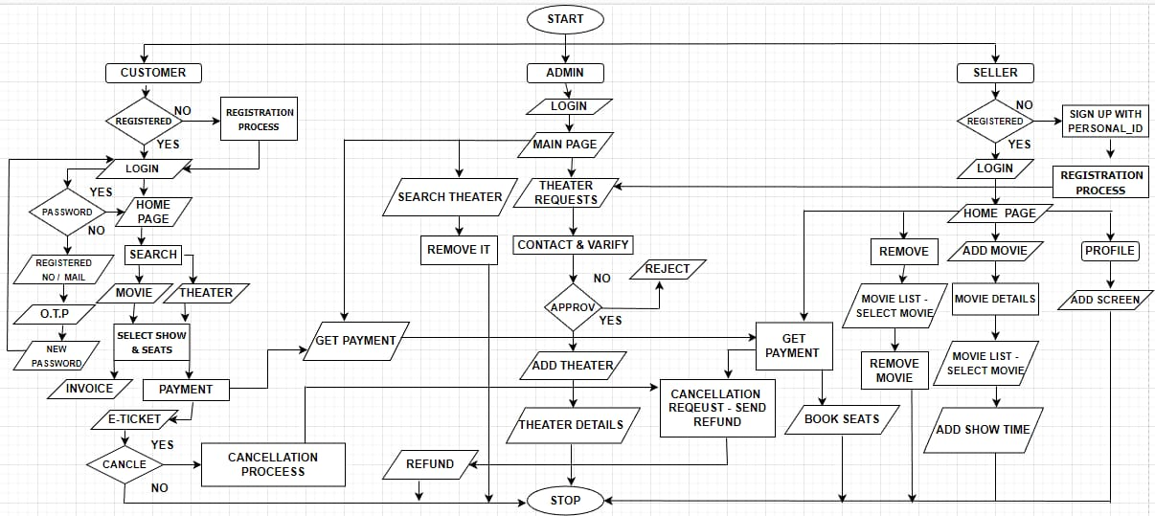

- LAYOUT: USER

1 LOGIN:
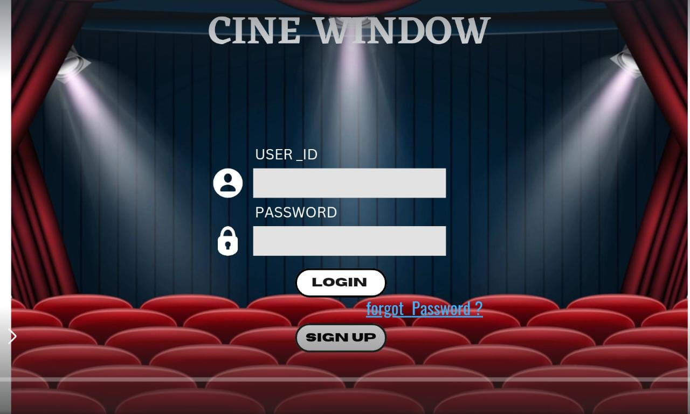

2 SIGN-UPS:
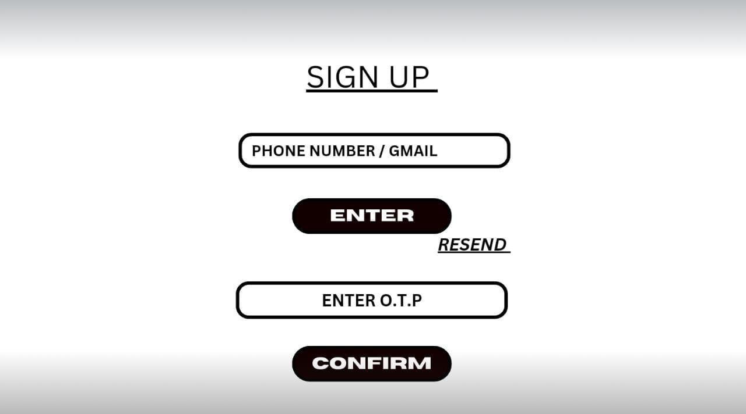

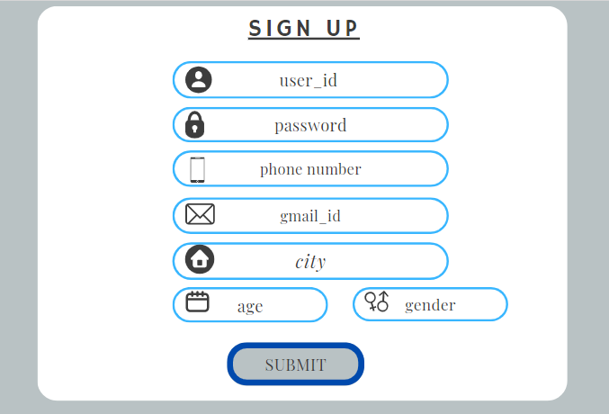

3 FORGET PASSWORD:
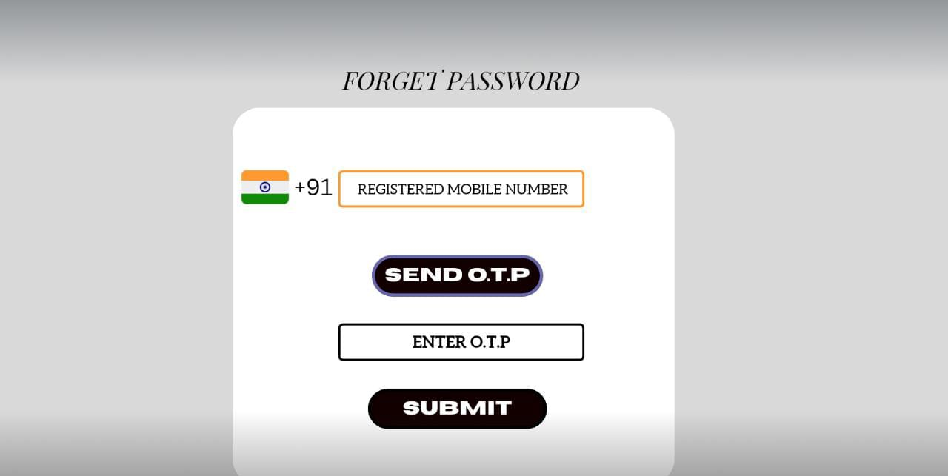

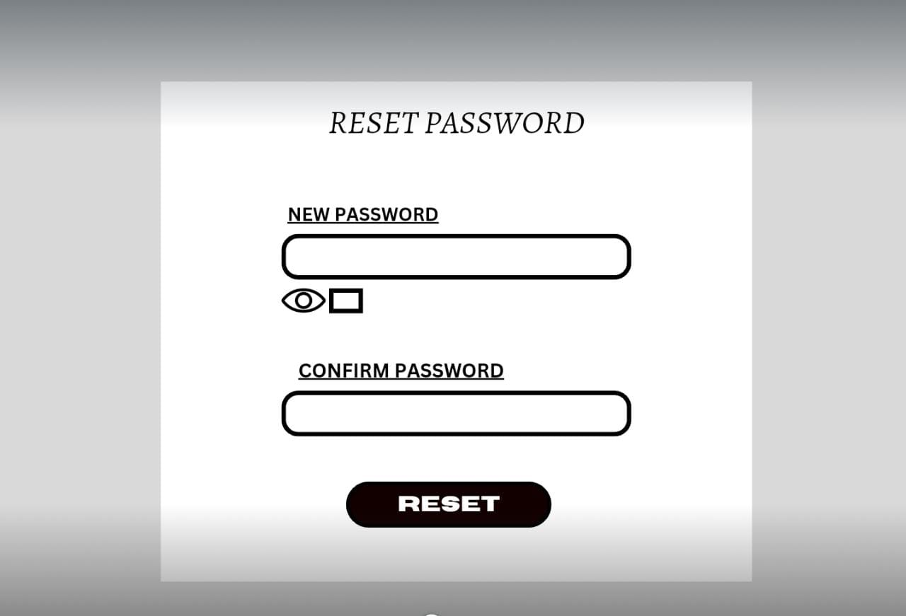

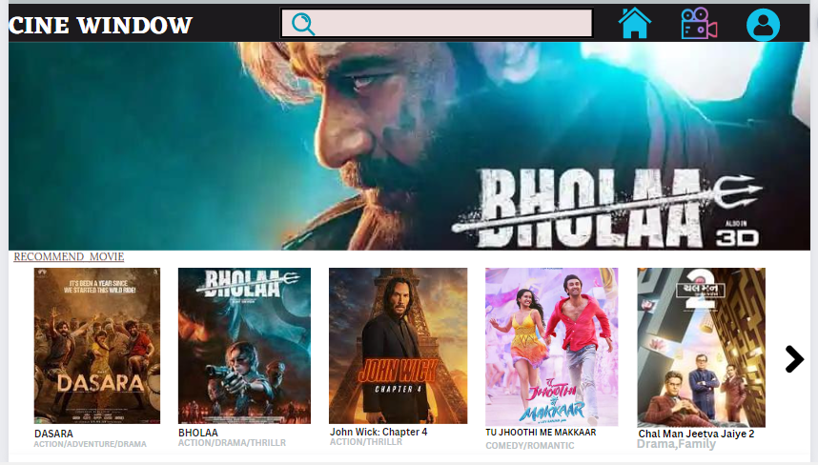
4 HOME PAGE

5.SEARCH
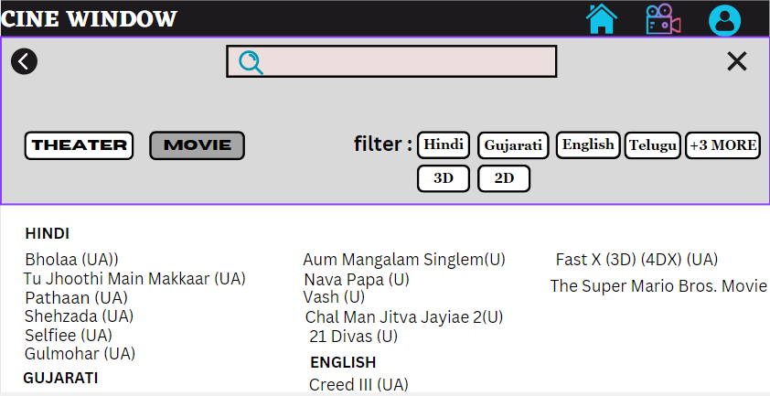

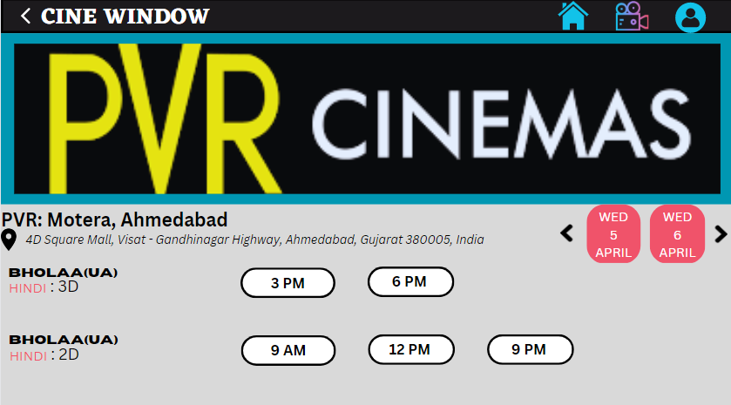
6. THEATRE SELECTION

7. MOVIE PAGE
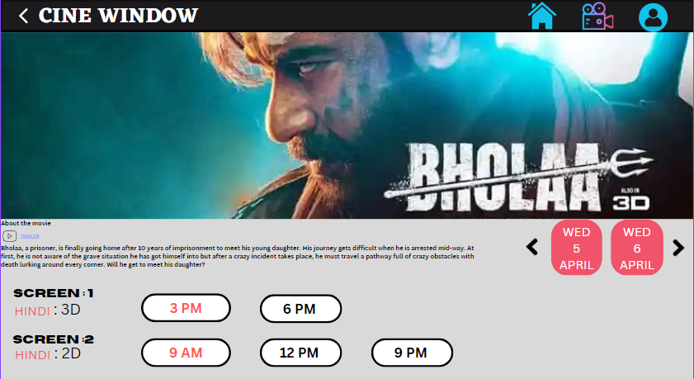

8. SEAT SELECTION
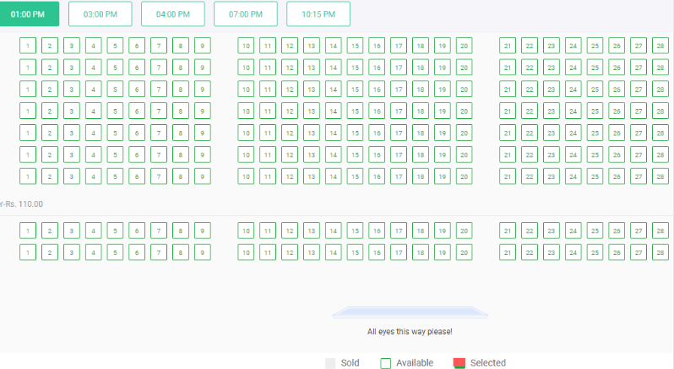

9. INVOICE
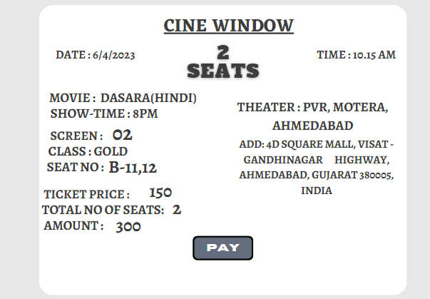

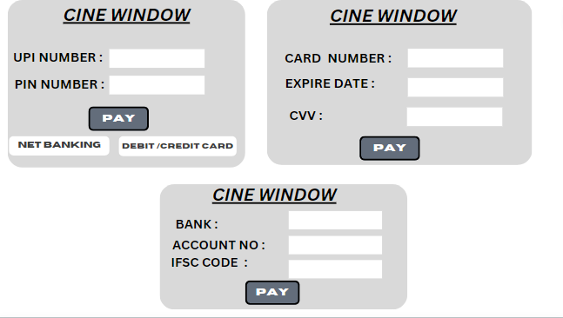
10 PAYMENT OPTION:

THEATRE OWNER:
1.LOGIN:


2.THEATER REGISTATION:
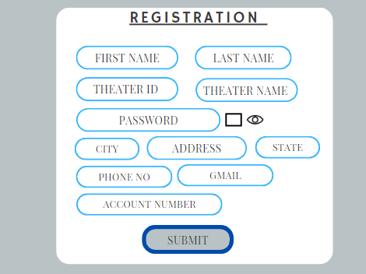
-

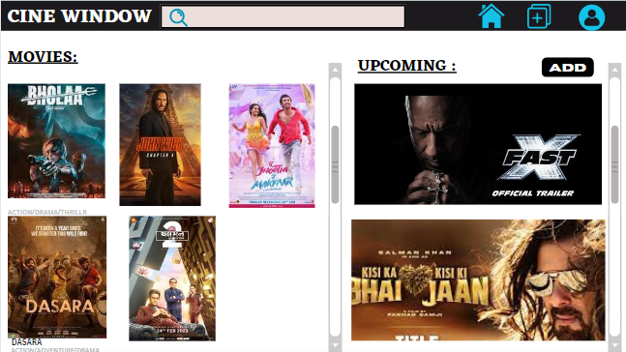
3. HOME PAGE:

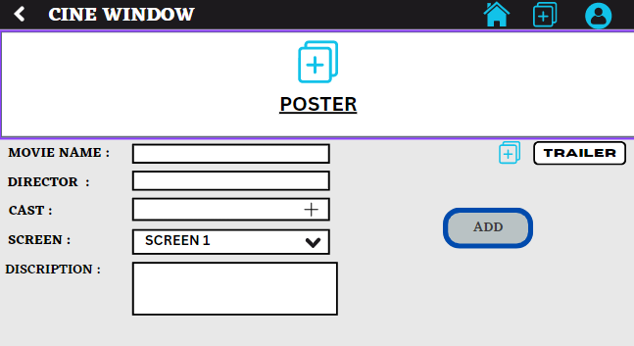
4. ADD MOVIE:

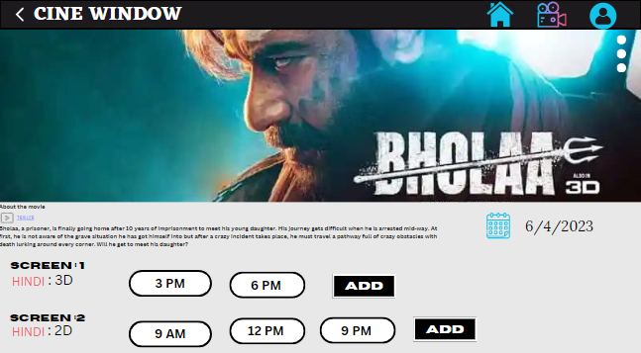
5. ADD SHOW:

ADMIN:

- LOGIN:



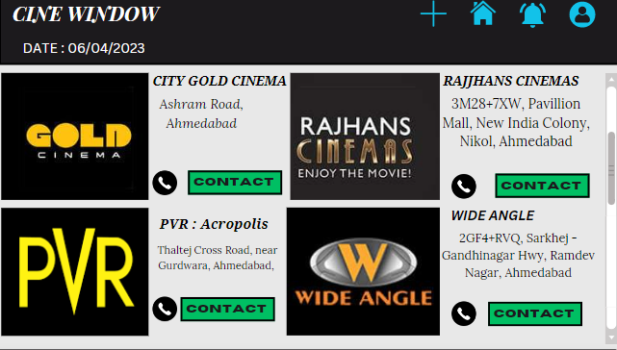
- HOME PAGE:

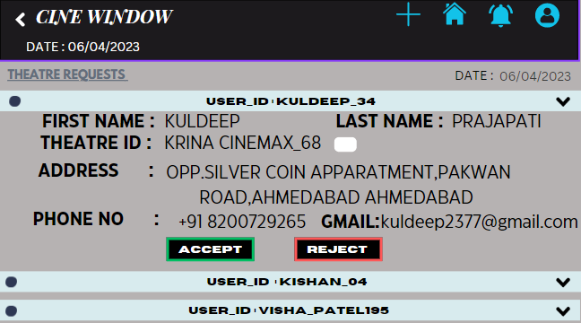
- THEATRE REQUESTS:

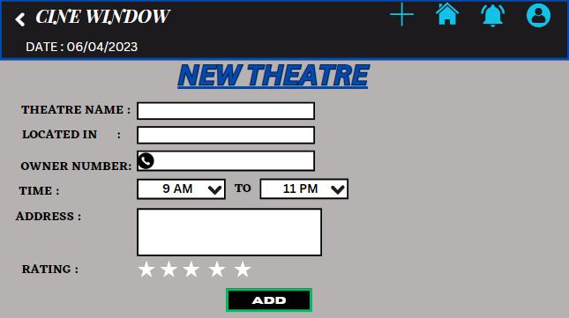
- ADD THEATRE:

- DATA FLOW DIAGRAM:

CONTEXT LEVEL:
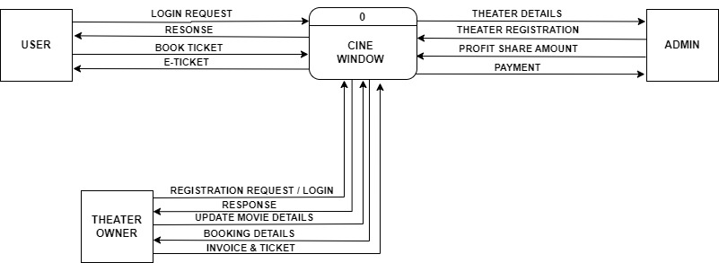

LEVEL 1:
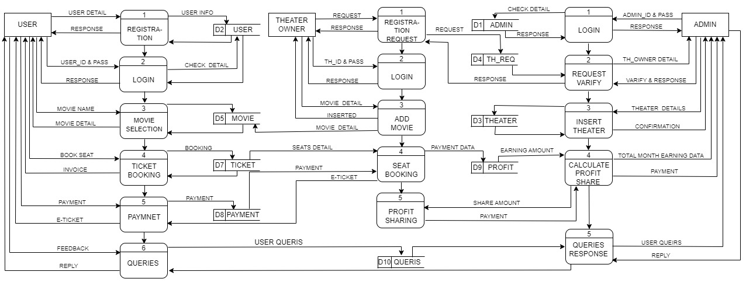
LEVEL 2:
USER:
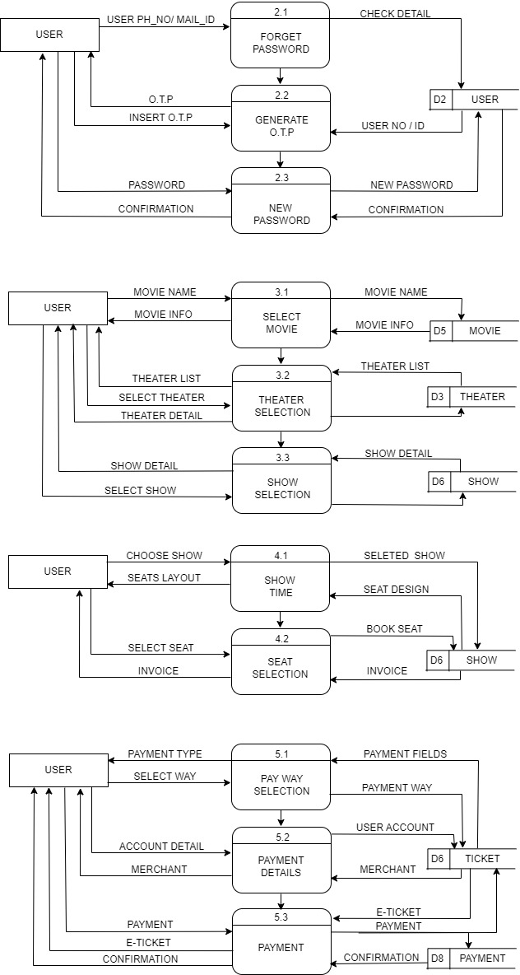

LEVEL 2:
THEATRE OWNER
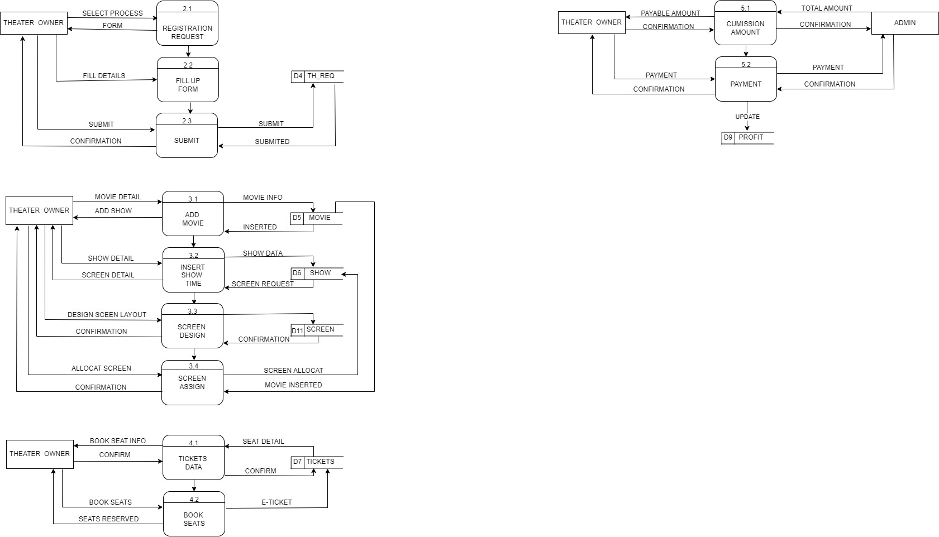

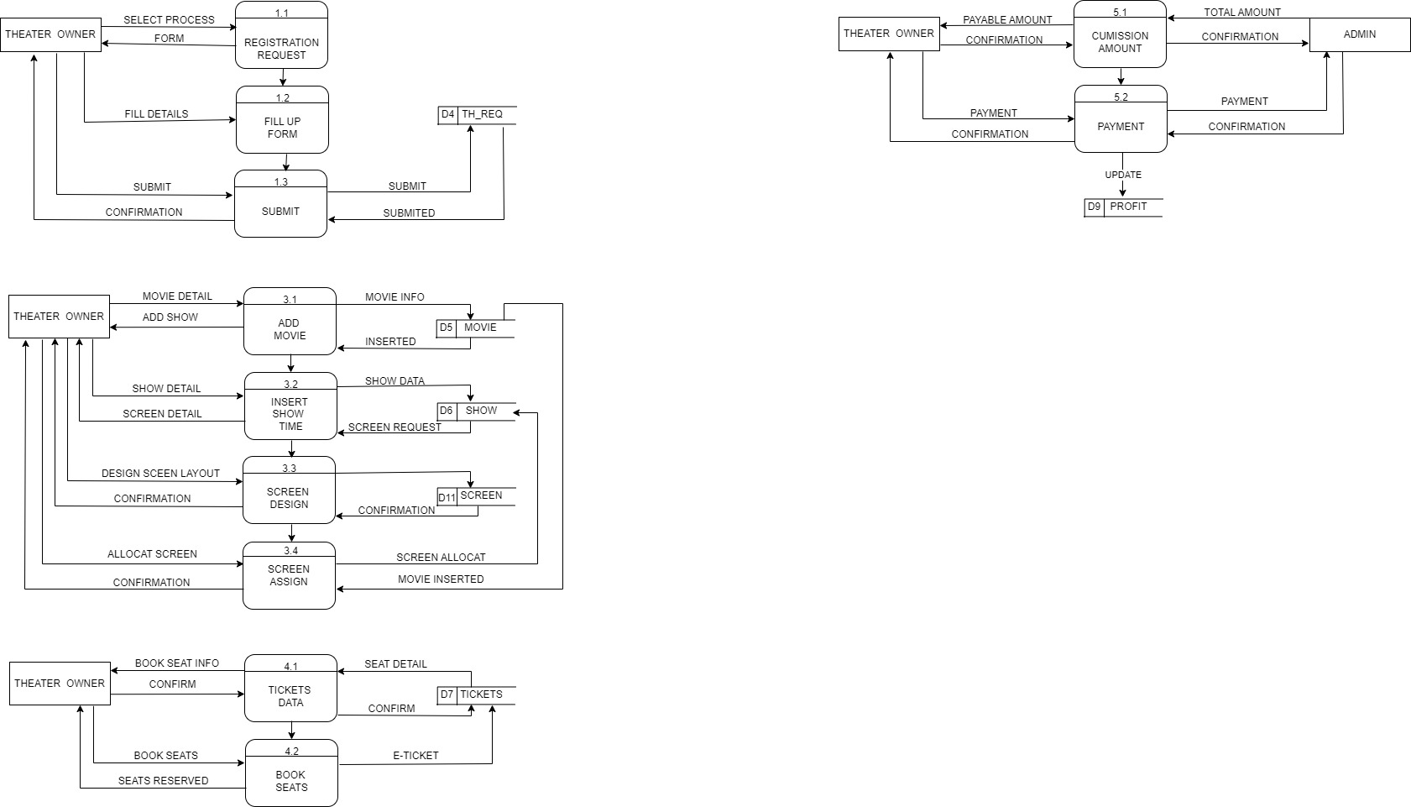


LEVEL 2:
ADMIN
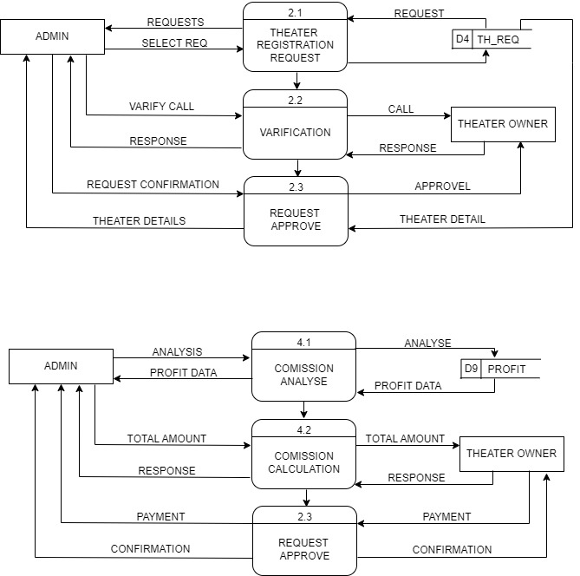

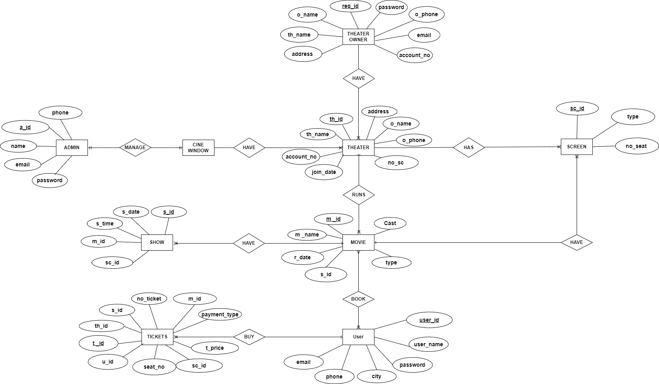
- E-R DIAGRAM:

- DATA DICTIONARY:

- Table name: ADMIN_TBL.
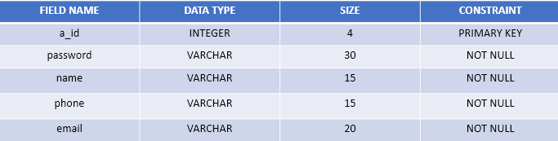
- Description: This table will store admin’s information.

- Table name: USER_TBL.
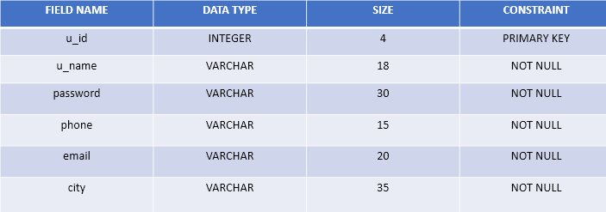
- Description: This table will store User’s information.

- Table name: THEATRE OWNER_TBL.
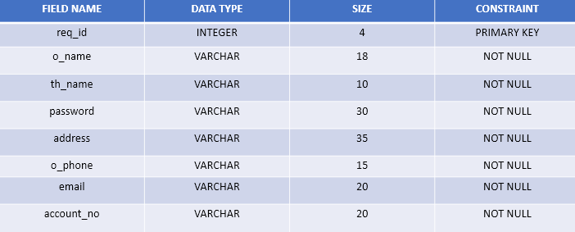
- Description: This table will store: theatre owner’s information.

- Table name: THEATRE_TBL.
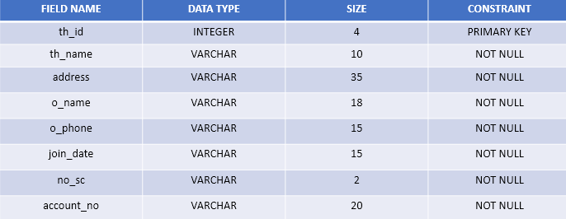
- Description: This table will store theatre’s information.

- Table name: MOVIE_TBL.
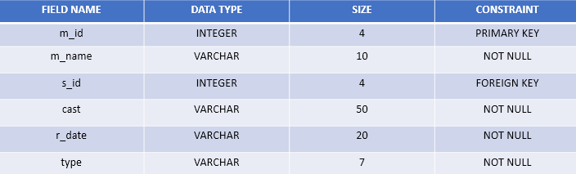
- Description: This table will store Movie’s information.

- Table name: TICKET_TBL.
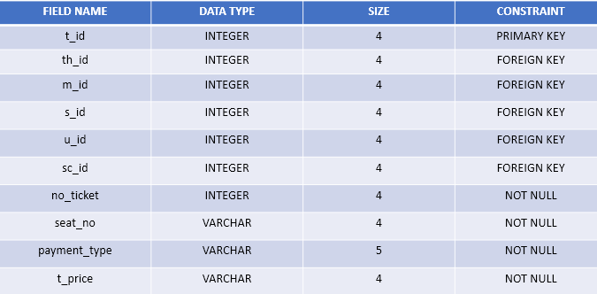
- Description: This table will store Ticket’s information.

- Table name: SCREEN_TBL.
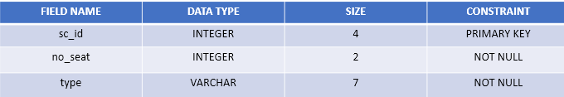
- Description: This table will store Screen’s information.

- Table name: SHOW_TBL.
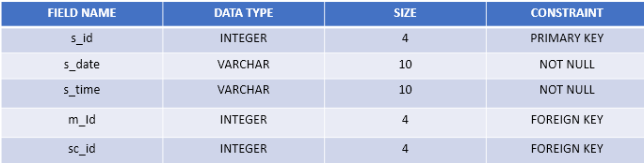
- Description: This table will store Show’s information.

- Table name: QUERY_TBL.
- Description: This table will store Ouery’s information.
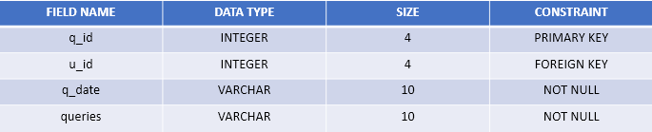

- Table name: PAYMENT_TBL.
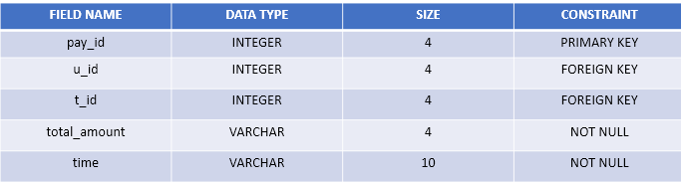
- Description: This table will store Payment’s information.

- Table name: PROFIT_TBL.
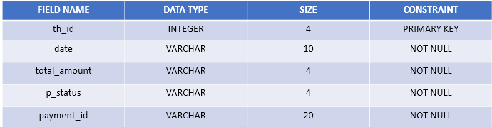
- Description: This table will store Profit’s information.
- Registration and Login Form with Coding

1. SYSTEM DESIGNS OF AUTHENTICATION: SIGNUP & LOGIN FORM

- SIGN-UP
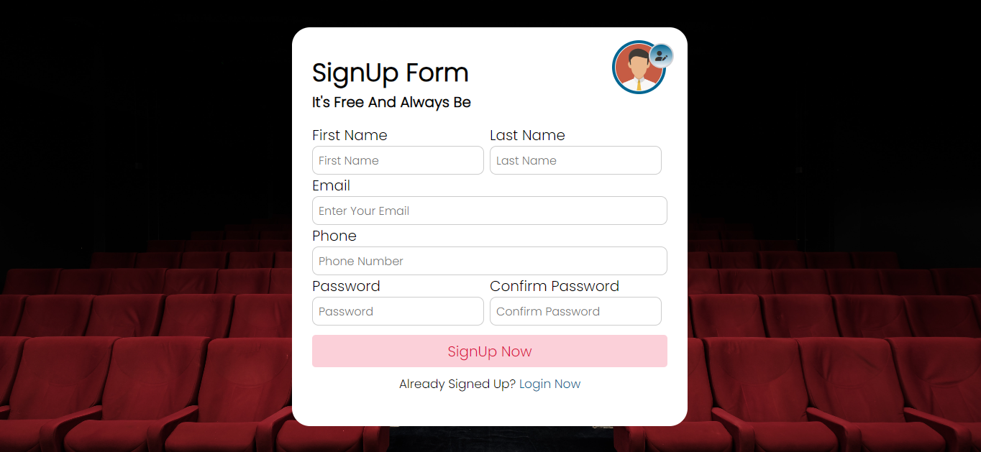

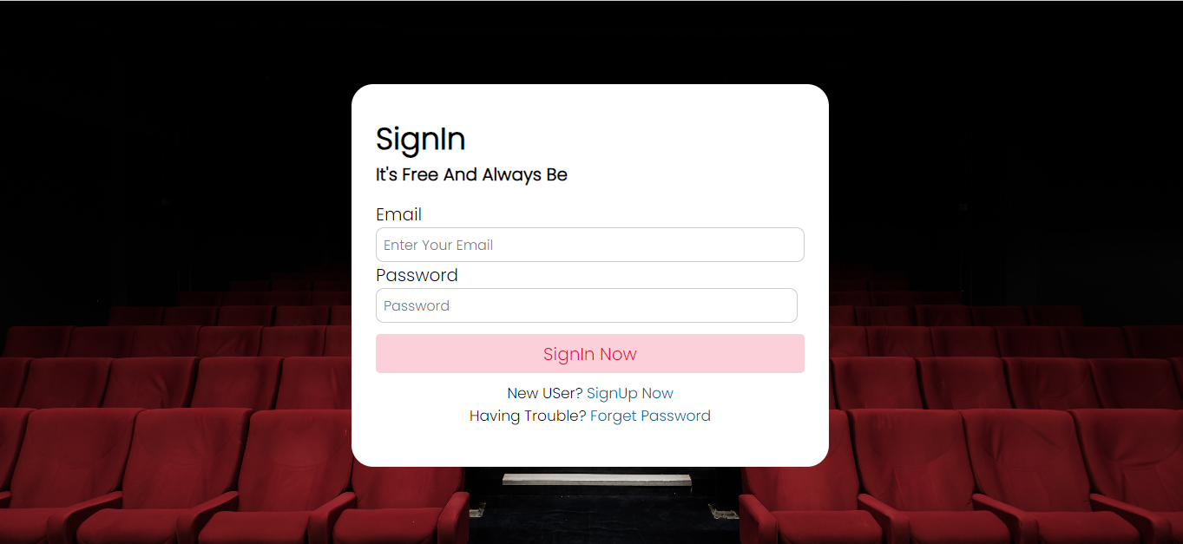
- LOG-IN

2. SYSTEM DESIGNS OF AUTHENTICATION: SIGNUP & LOGIN FORM

- Sign-up.

<!DOCTYPE html>
<html lang="en">
<head>
<meta charset="UTF-8">
<meta http-equiv="X-UA-Compatible" content="IE=edge">
<meta name="viewport" content="width=device-width, initial-scale=1.0">
<!-- <link rel="stylesheet" href="../css/style.css"> -->
<link rel="icon" type="image/x-icon" href="../static_imgs/fav.png">
<link rel="stylesheet" href="../css/styles.css">
<title>CineWindows | Login</title>
</head>
<body>
<div class="form">
<h2>SignIn</h2>
<p>It's Free And Always Be</p>
<form action="">
<div class="error-text">
Error
</div>
<div class="input">
<label>Email</label>
<input type="email" name="email" placeholder="Enter Your Email" required>
</div>
<div class="grid-details">
<div class="input">
<label>Password</label>
<input type="password" name="pass" placeholder="Password" required>
</div>
</div>
<div class="submit" >
<input type="submit" value="SignIn Now" class="button">
</div>
</form> <div class="link">
New USer?
<a href="register.php">SignUp Now</a><br>
Having Trouble?
<a href="forget_password/fp_frontend.php">Forget Password</a>
</div>
</div>
<script src="../js/log_5.js"></script>
</body>
</html>

- Log-in
<?php
session_start();
include_once 'db.php';
$fname = $_POST['fname'];
$lname = $_POST['lname'];
$email = $_POST['email'];
$phone = $_POST['phone'];
$password = md5($_POST['pass']);
$cpassword = md5($_POST['cpass']);
//chacking fields are not empty
if(!empty($fname) && !empty($lname) && !empty($email) && !empty($phone) && !empty($password) && !empty($cpassword) )
{ //if email is valid
if(filter_var($email,FILTER_VALIDATE_EMAIL))
{ //checking if email already present
$pra = "SELECT email FROM user WHERE email = '{$email}'";
$sql = mysqli_query($conn,$pra);
if(mysqli_num_rows($sql)>0)
{
echo "$email ~ Already Exists";
}
else
{
$prat = "SELECT phone FROM user WHERE phone = '{$phone}'";
$ph = mysqli_query($conn,$prat);
if(mysqli_num_rows($ph)>0)
{
echo "$phone ~ Already Exists";
}
else
{
if($password == $cpassword )
{
//let us check user upload file or not
if(isset($_FILES['image']))
{
$img_name = $_FILES['image']['name'];
$img_typ = $_FILES['image']['type'];
$tmp_name = $_FILES['image']['tmp_name'];
$img_explode = explode('.',$img_name);
$img_extension = end($img_explode);
$extensions = ['png','jpg','jpeg'];
if(in_array($img_extension,$extensions) === true)
{
$time = time();
$newimagename = $time . $img_name;
$folder = '../img/' .$newimagename;
if(move_uploaded_file($tmp_name, $folder))
{
$random_id = rand(100,1000);//creating a user unique id
$otp = mt_rand(1111,9999);//creating otp 4 digit
$inn = "INSERT INTO user (user_id,fname,lname,email,phone,password,image,otp) VALUES ({$random_id},'{$fname}','{$lname}','{$email}','{$phone}','{$password}','{$folder}','{$otp}')";
$sql2 = mysqli_query($conn,$inn);
if($sql2)
{
// $pratham = ;
$sql3 = mysqli_query($conn, "SELECT * FROM user WHERE email = '{$email}'");
if(mysqli_num_rows($sql3)>0)
{
$row = mysqli_fetch_assoc($sql3);
$_SESSION['unique_id'] = $row['user_id'];
$_SESSION['email'] = $row['email'];
$_SESSION['otp'] = $row['otp'];

//email session
if($otp)
{
$headers = "From : CineWindows";
$receiver = $email;
$subject = "CineWindows🎥 OTP Registration : ".$otp;
$body = "ThankYou For Choosing Us (:\nDon't Share Your OTP With AnyOne\nName : "." $fname $lname \nEmail : "." $email\n"."OTP : " . $otp."\nWe Are Happy To Have You\nMade With Love😊💕❤️";
$sender = "From : cinewindows121@gmail.com";

if(mail($receiver,$subject,$body,$sender,$headers))
{
echo "Success";
}
else
{
echo "Problem";
}
}
//email end
}
else{
echo "Somthing Went Wrong";
}
}
else
{
echo "something Went Wrong";
}
}
}
else
{
echo "Image Extension Does Not Matched";
}
}
else
{
echo "Please Select An Profile Image";
}
}
else
{
echo "Password Is Not Matching!!";
}
}

}
}
else
{
echo "$email ~ This is Not A Valid Email";
}
}
else
{
echo "All Fields Are required";
}
?>

3. SYSTEM ADMINISTRATION FORM DESIGN AND CODING

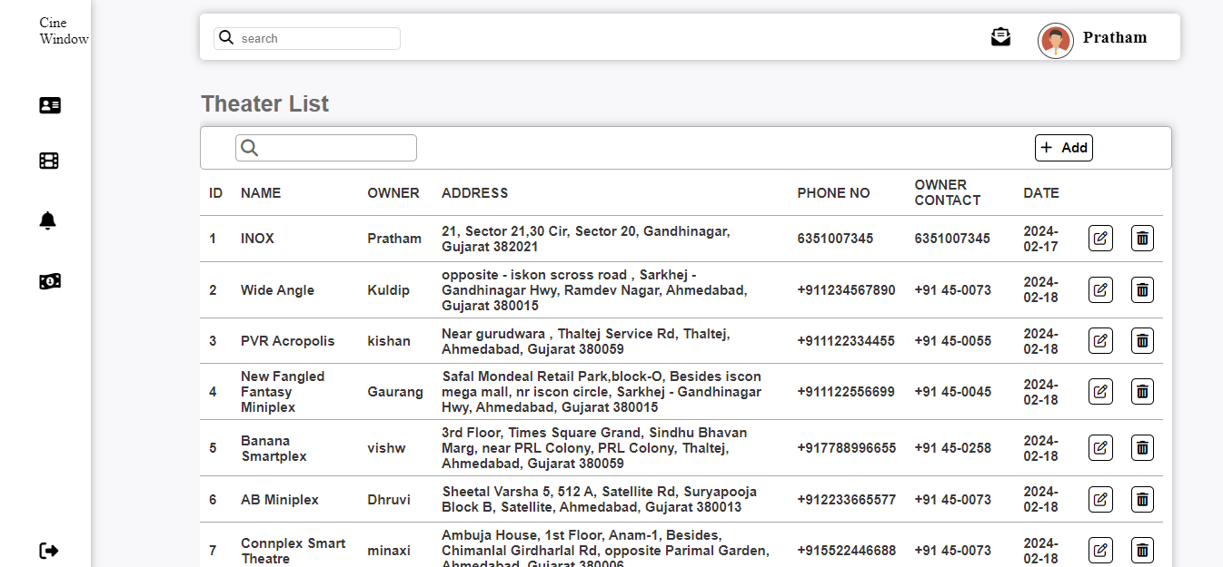
- ADMIN PAGE

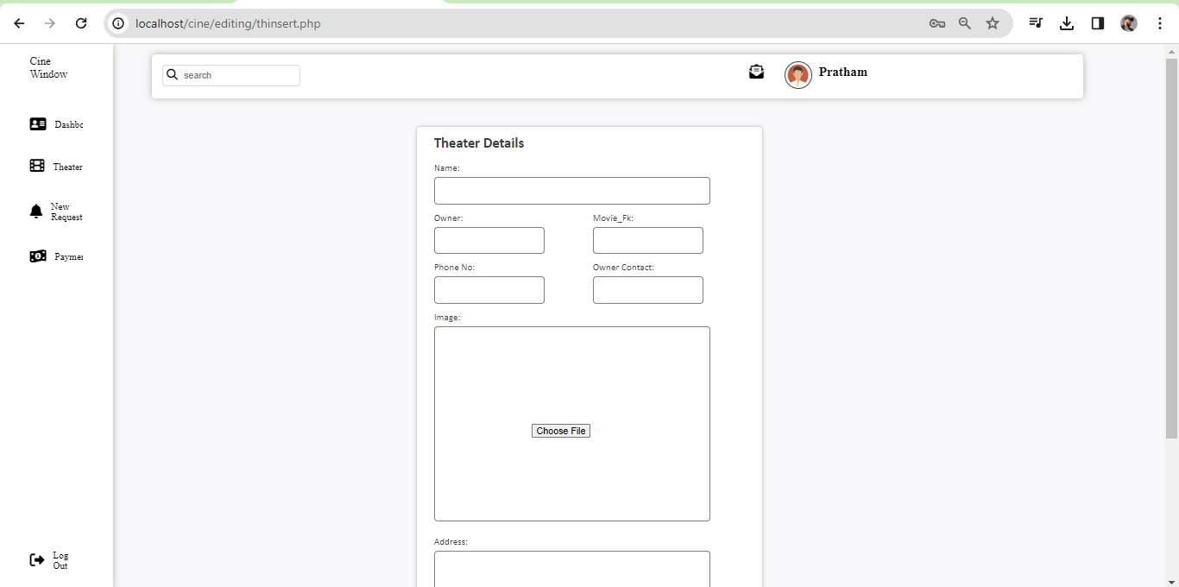
- ADMIN ADD THEATER SERVICE

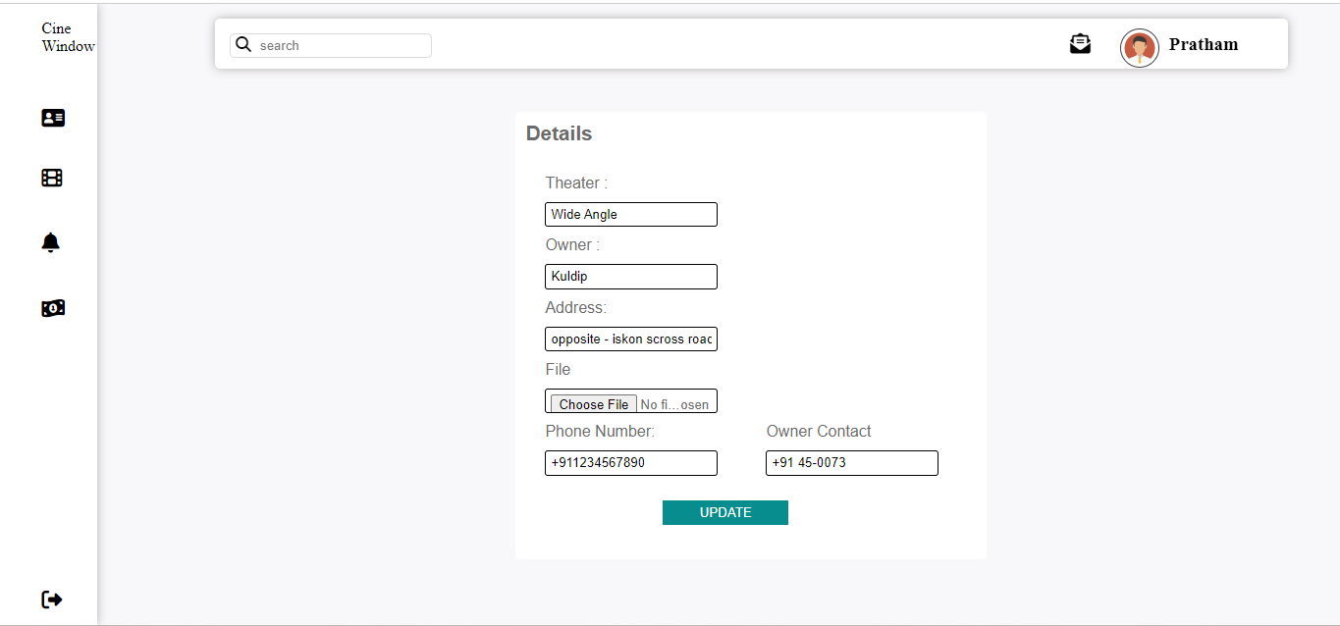
- ADMIN UPDATE THEATER LIST

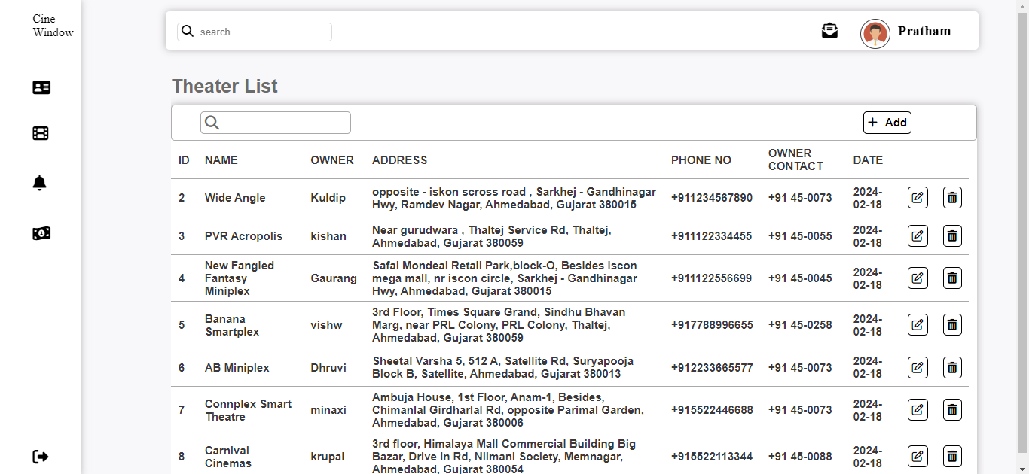
- ADMIN THEATER DELETE

Coding

Insert
?php require 'cwheader.php' ?>
<?php
if (isset($_GET['id'])) {
$th_id = $_GET['id'];
$sqlDelete = "DELETE FROM cinema WHERE cinema_id='$th_id'";
if (mysqli_query($conn, $sqlDelete)) {
header("location:theater.php");
} else {
header("location:theater.php");
}}
?>
<?php
if (isset($_POST['insert'])) {
$th_name = $_POST['th_name'];
$own_name = $_POST['own_name'];
$th_address = $_POST['th_address'];
$th_phone = $_POST['th_phone'];
$own_phone = $_POST['own_phone'];
$th_pass = $_POST['th_pass'];
//inserting image
$img_name = $_FILES['file']['name'];
$img_typ = $_FILES['file']['type'];
$tmp_name = $_FILES['file']['tmp_name'];
$img_explode = explode('.', $img_name);
$img_extension = end($img_explode);
$extensions = ['png', 'jpg', 'jpeg'];
if (in_array($img_extension, $extensions) === true) {
$time = time();
$newimagename = $time . $img_name;
$folder = '../img/' . $newimagename;
move_uploaded_file($tmp_name, $folder);
}
$th_img = $_POST['th_img'];
$sqlinsert = "INSERT INTO cinema
(cinema_name,own_name,cinema_location,cinema_phone,own_phone,movie_fk) VALUES ('$th_name','$own_name','$th_address','$th_phone','$own_phone','$th_pass')";
if (mysqli_query($conn, $sqlinsert)) {
header("Location: theater.php");
} else {
header("Location: threq.php");
}
}

Update
?php require 'cwheader.php'; ?>
<!DOCTYPE html>
<html lang="en">
<head>
<meta charset="UTF-8">
<meta name="viewport" content="width=device-width, initial-scale=1.0">
<title>Update Theater</title>
<link rel="stylesheet" href="cw.css">
<script src="https://kit.fontawesome.com/61163db8e0.js" crossorigin="anonymous"></script>
</head>
<body>
<main>
<div id="updatetheater">
<h5>Details </h5>
<?php
if (isset($_GET['id'])) {
$id = $_GET['id'];
$sqlupdate = "SELECT * FROM cinema WHERE cinema_id = $id";
$result = mysqli_query($conn, $sqlupdate);
if (!$result) {
die("query Failed" . mysqli_error());
} else {
while ($row = mysqli_fetch_assoc($result)) {
?>
<form method="post" action="thupdate.php?id_new=<?php echo $id; ?>" enctype="multipart/form-data">
<div class="show">
<lable>Theater :</lable>
<input type="text" value="<?php echo $row['cinema_name']; ?>" name="th_name"> </div>
<div class="show">
<lable>Owner :</lable>
<input type="text" value="<?php echo $row['own_name']; ?>" name="own_name">
</div>
<div class="show">
<lable>Address:</lable>
<input type="text" value="<?php echo $row['cinema_location']; ?>" name="th_address">
</div>
<?php
if (isset($_POST['thupdate'])) {
if (isset($_GET['id_new'])) {
$id_new = $_GET['id_new'];
}
$th_name = $_POST['th_name'];
$own_name = $_POST['own_name'];
$th_address = $_POST['th_address'];
$th_phone = $_POST['th_phone'];
$own_phone = $_POST['own_phone'];
//image insert

$img_name = $_FILES['file']['name'];
$img_typ = $_FILES['file']['type'];
$tmp_name = $_FILES['file']['tmp_name'];
$img_explode = explode('.', $img_name);
$img_extension = end($img_explode);
$extensions = ['png', 'jpg', 'jpeg','webp'];

if (in_array($img_extension, $extensions) === true) {
$time = time();
$newimagename = $time . $img_name;
$folder = '../img/' . $newimagename;
move_uploaded_file($tmp_name, $folder);
}
$sql = "UPDATE cinema SET cinema_name='$th_name', own_name = '$own_name', cinema_location = '$th_address',cinema_phone = '$th_phone',own_phone = '$own_phone' ,cinema_img='$folder' WHERE cinema_id= '$id_new'";
if (mysqli_query($conn, $sql)) {
header("Location: theater.php");
} else {
header("Location: thupdate.php");
}
}
?>
</main>
</body>
</html>

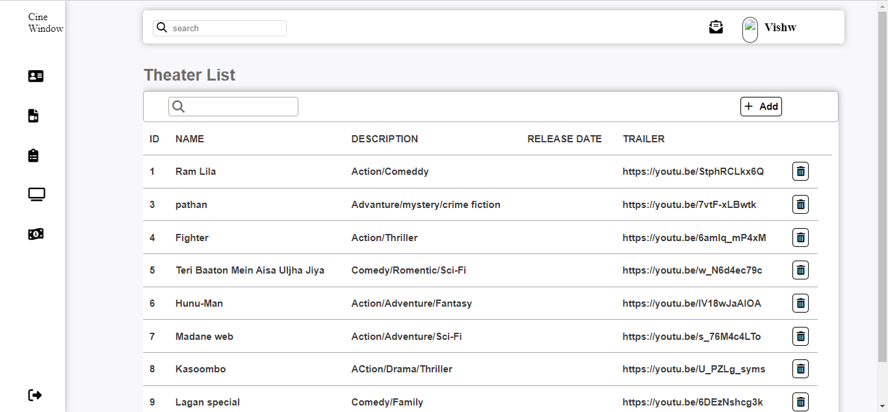
- THEATER OWNER MOVIE PAGE

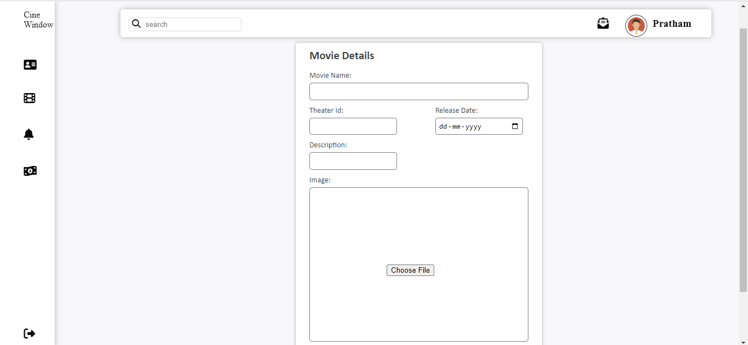
- THEATER OWNER ADD MOVIE PAGE


- THEATER OWNER DELETE MOVIE PAGE

Coding

<?php require'cwheader.php'?>
<?php
?>
<!DOCTYPE html>
<html lang="en">
<head>
<meta charset="UTF-8">
<meta name="viewport" content="width=device-width, initial-scale=1.0">
<script src="https://kit.fontawesome.com/61163db8e0.js" crossorigin="anonymous"></script>
<link rel="stylesheet" href="cw.css">
</head>
<body>
<main>
<div>
<div class="forms">
<div class="insertform">

<h5>Movie Details</h5>
<form action="movieinsert.php" method="post">

<div class="input">
<label>Movie Name:</label>
<input type="text" name="movie_name">
</div>
<div class="fieldinput">
<div class="input">
<label>Theater Id:</label>
<input type="text" name="th_id">
</div>
<div class="input">
<label>Release Date:</label>
<input type="date" name="r_date">
</div>
</div>

<div class="fieldinput">
<div class="input">
<label>Description:</label>
<input type="text" name="description">
</div>
</div>
<div class="decimbox">
<div class="input">
<label>Image:</label>
<input type="file" name="movie_img" id="img">
</div>
</div>
<button type="submit" name="insert" id="insertbtn">Add</button>
</form>
</div>
</div>
</div>
</main>
</body>
</html>

4. SYSTEM ADMINISTRATION FORM (SEARCHING)

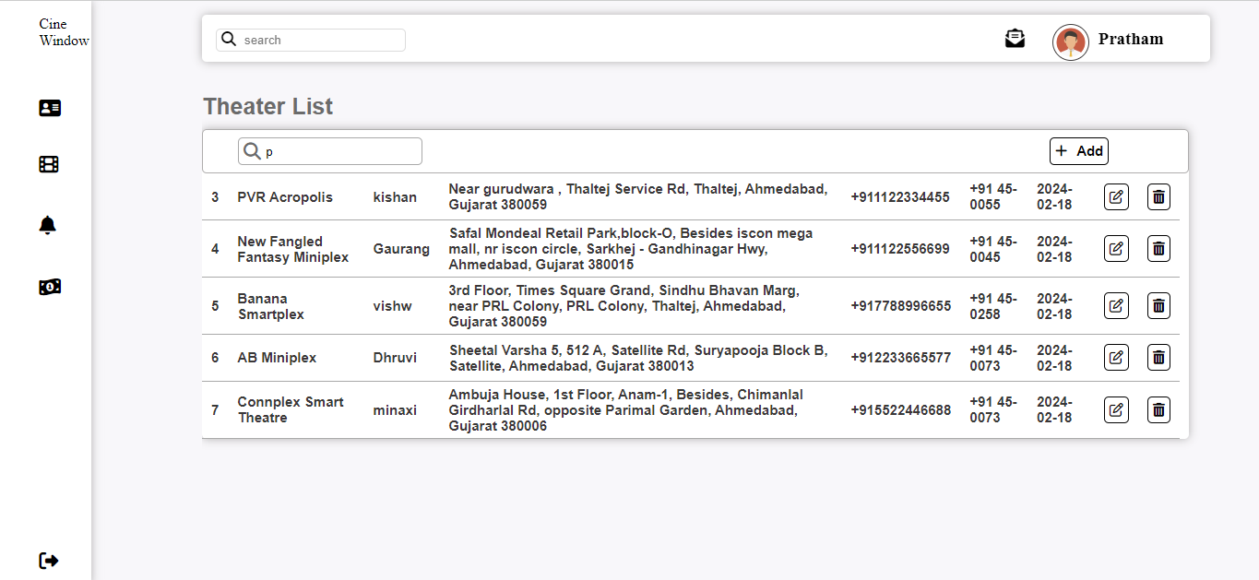
- ADMIN THEATER SERVICE SEARCH BAR

- THEATER OWNER SEARCH BAR
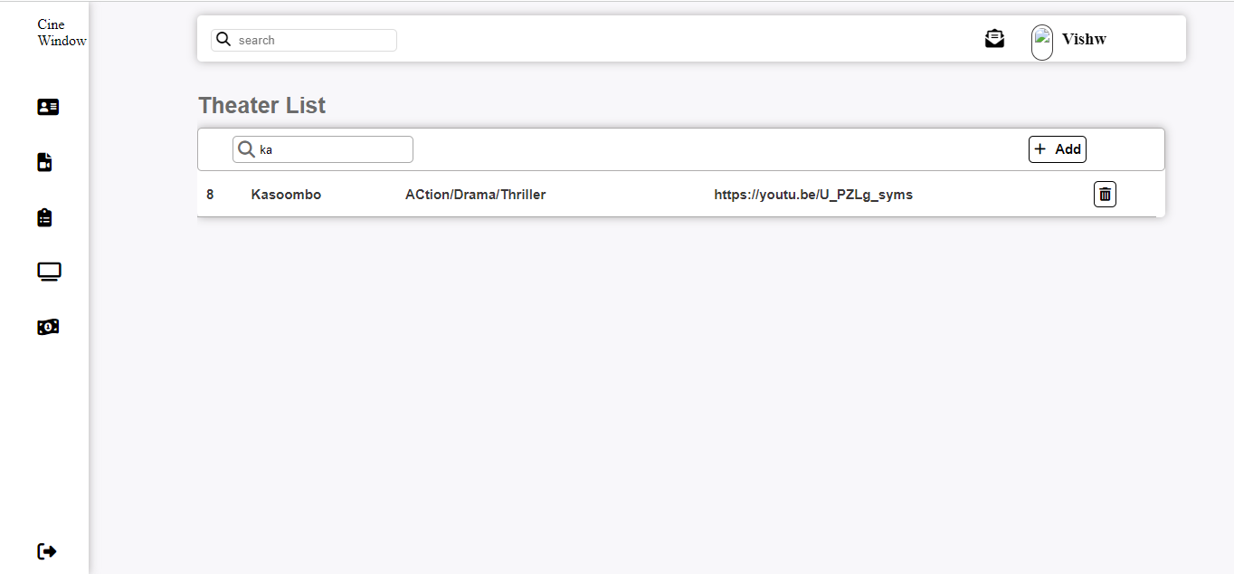

Coding

function search()
{
var input,filter,table,tr,td,i,textvalue;
input = document.getElementById("search");
filter = input.value.toUpperCase();
table = document.getElementById("table");
tr = table.getElementsByTagName("tr");
for(i=0;i<tr.length;i++)
{
td = tr[i].getElementsByTagName("td")[3];
if(td)
{
textvalue = td.textContent;
if(textvalue.toUpperCase().indexOf(filter) > -1)
{
tr[i].style.display="";
}
else
{
tr[i].style.display="none";
}
}
}
}
function thsearch()
{
var input,filter,table,tr,td,i,textvalue;
input = document.getElementById("search");
filter = input.value.toUpperCase();
table = document.getElementById("table");
tr = table.getElementsByTagName("tr");
for(i=0;i<tr.length;i++)
{
td = tr[i].getElementsByTagName("td")[1];
if(td)
{
textvalue = td.textContent;
if(textvalue.toUpperCase().indexOf(filter) > -1)
{
tr[i].style.display="";
}
else
{
tr[i].style.display="none";
}
}
}
}

5. SYSTEM REPORT GENERATION

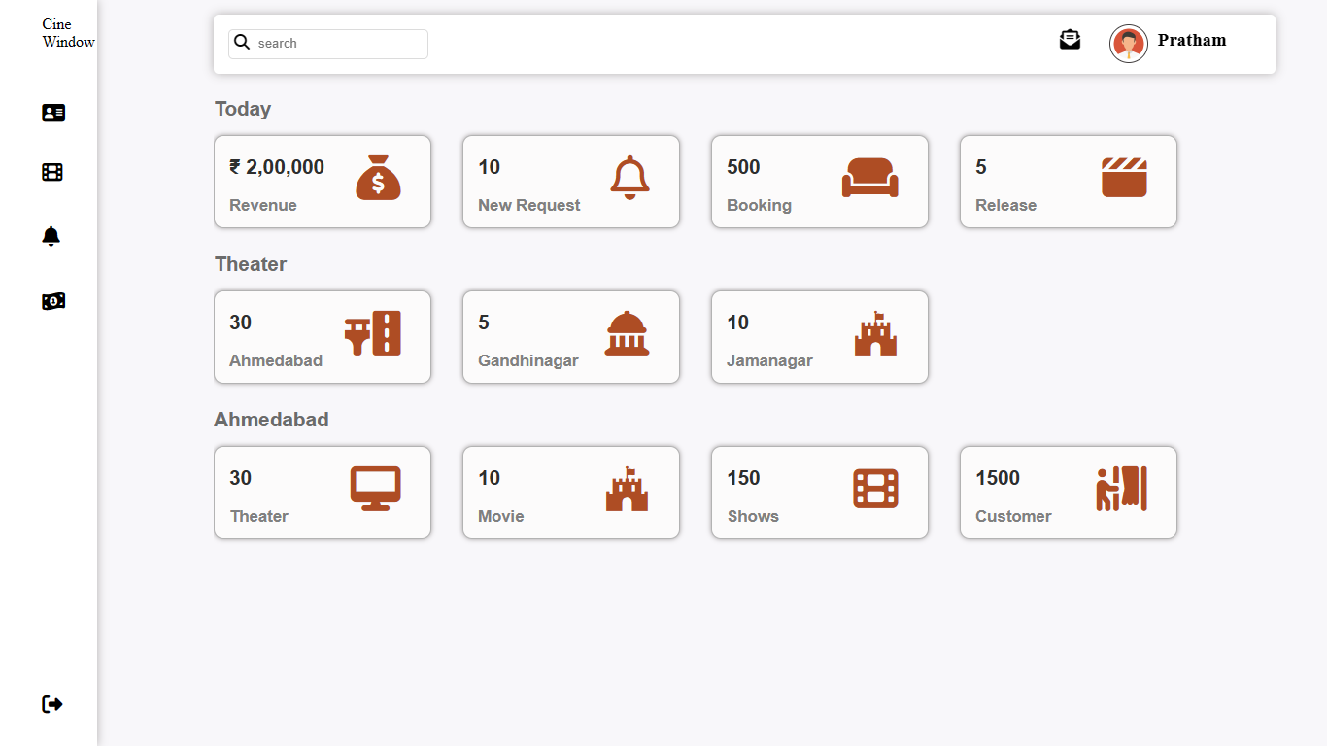

6. SYSTEM VALIDATIONS

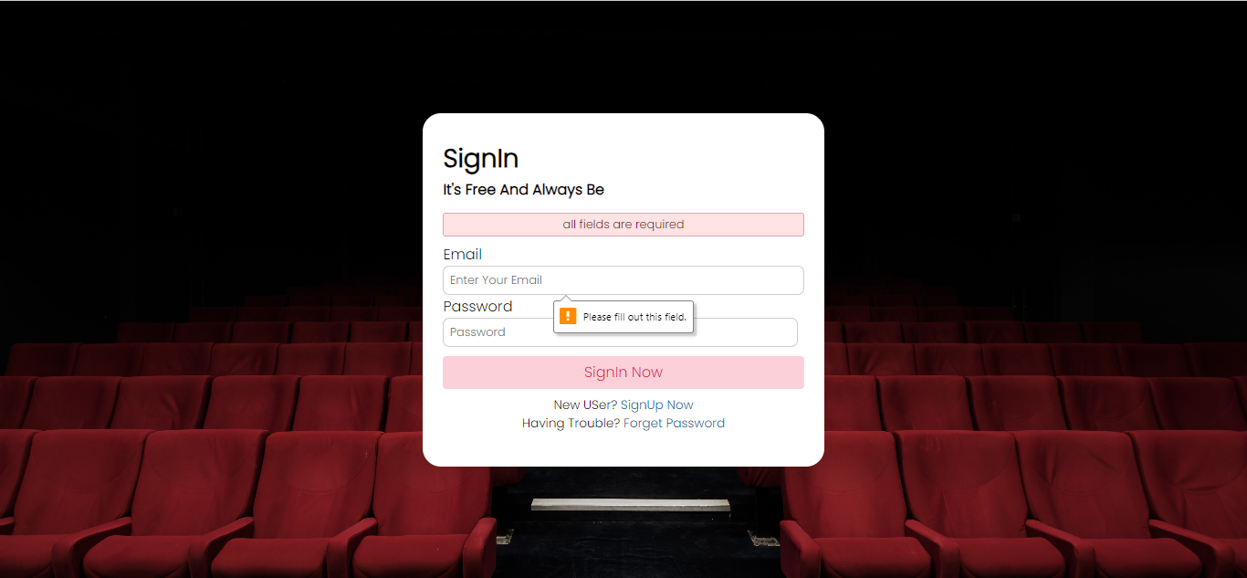
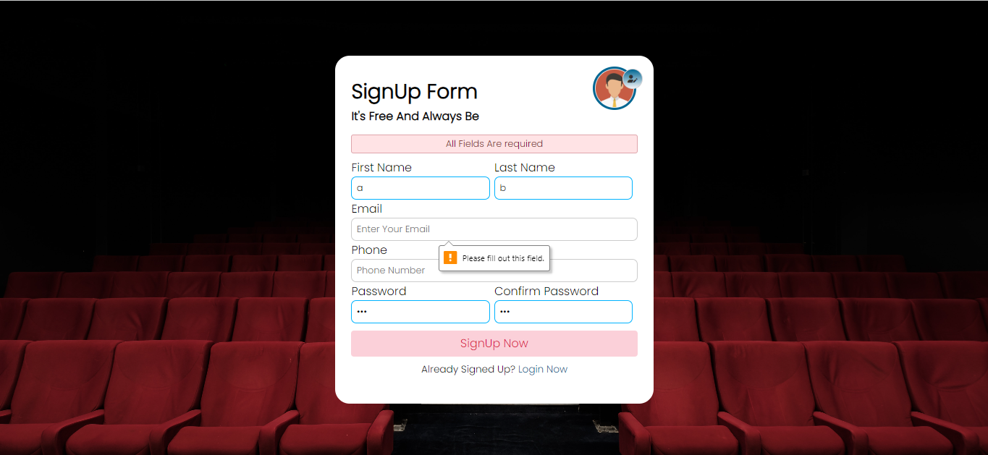

CODING

if (empty($unique)){
header("location: login.php");
}

AND

//username variables
$unique_id = $_GET['user_id'];
if (empty($unique_id)){
header("location: index.php");
}

7. FEATURES

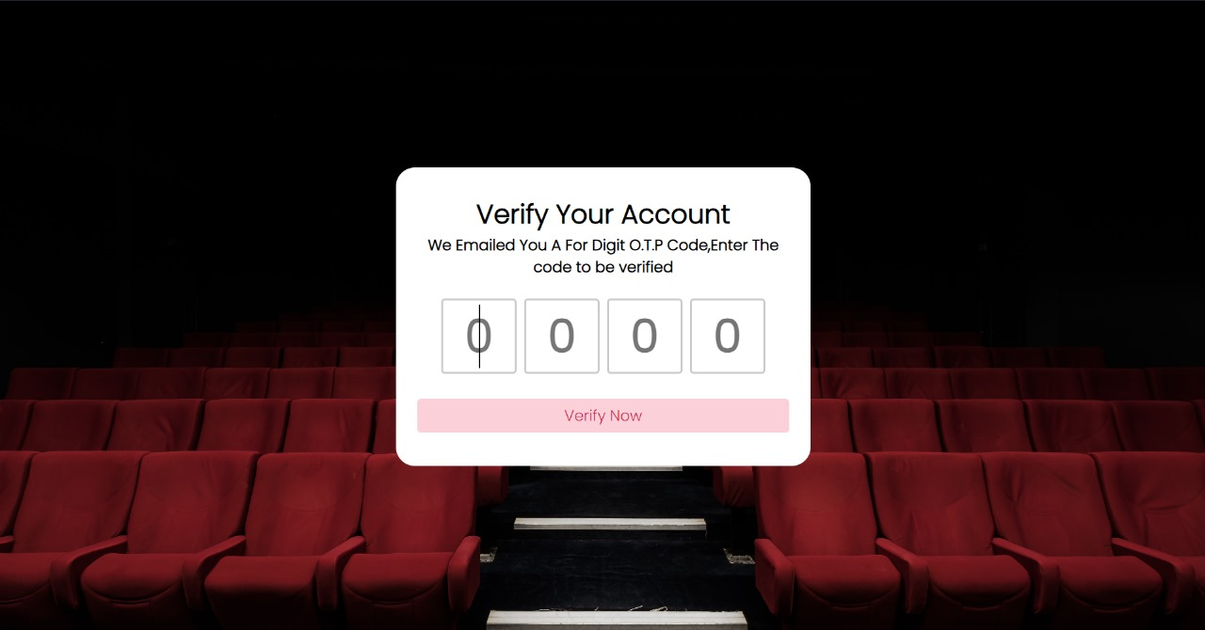
(OTP)
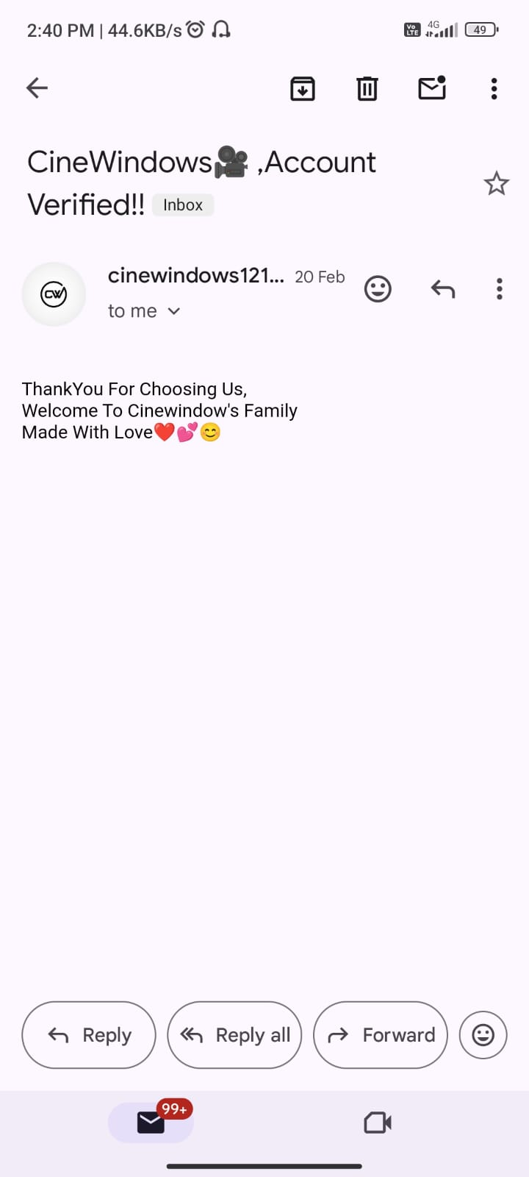
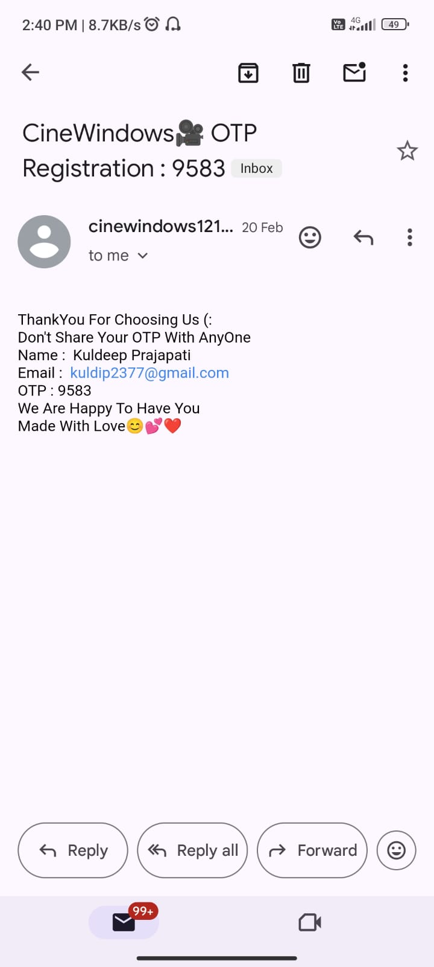

CODING

<?php
include_once 'db.php';
session_start();
$otp1 = $_POST['otp1'];
$otp2 = $_POST['otp2'];
$otp3 = $_POST['otp3'];
$otp4 = $_POST['otp4'];
$unique_id = $_SESSION['unique_id'];
$session_otp = $_SESSION['otp'];
$otp = $otp1.$otp2.$otp3.$otp4;
if(!empty($otp))
{ //matching otp
if($otp == $session_otp)
{
$op = "SELECT * FROM user WHERE user_id = '{$unique_id}' AND otp = '{$otp}' ";
$sql = mysqli_query ($conn,$op);
//if matched
if(mysqli_num_rows($sql)>0)
{
$null_otp = 0;
$update = "UPDATE user SET verify = '1' , otp = '{$null_otp}' WHERE user_id = '{$unique_id}' ";
$sql2 = mysqli_query($conn,$update);
if($sql2)
{
$row = mysqli_fetch_assoc($sql);
if($row)
{
$receiver = $row['email'];
$subject = "CineWindows🎥 ,Account Verified!!";
$body = "ThankYou For Choosing Us, \nWelcome To Cinewindow's Family\nMade With Love❤️💕😊";
$sender = "From : cinewindows121@gmail.com";
if(mail($receiver,$subject,$body,$sender))
{
$unique_id = $_SESSION['unique_id'];
$_SESSION['unique_id'] = $row['user_id'];
$_SESSION['verification_status'] = $row['verify'];
echo "Success";
}
else
{
echo "No Internet Connection!!😔";
}
}}}
} else {
echo "O.T.P Not Matched";
}
}
else{
echo "Enter Otp";}?>
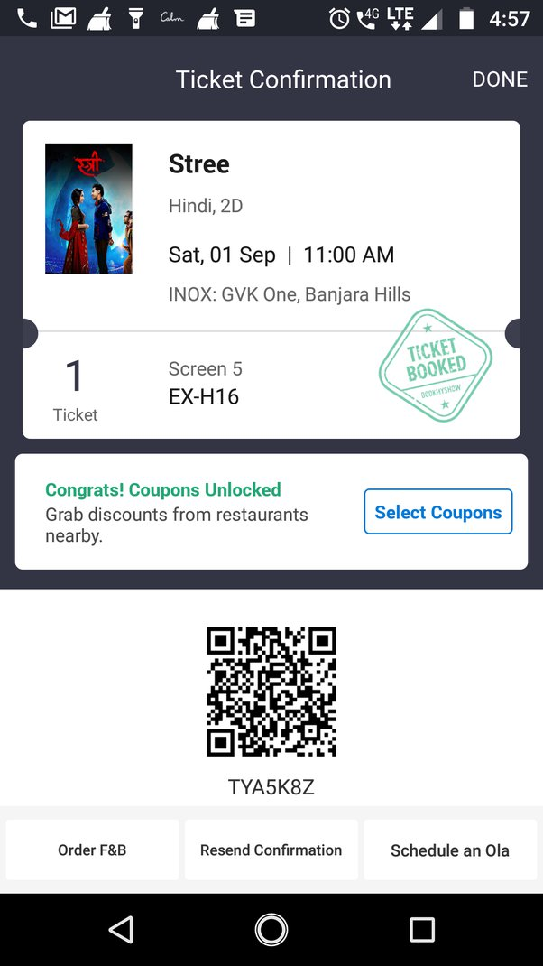
(BILLING)

WORDPRESS
1 LOGIN
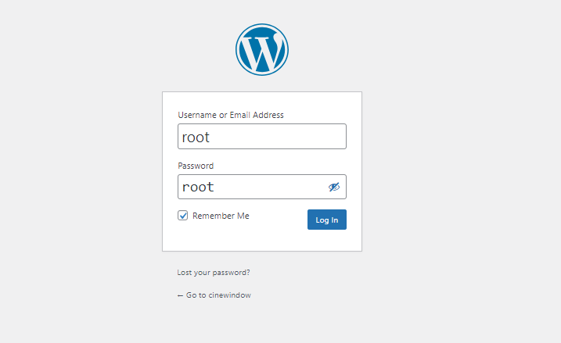

2 DASHBOARDS
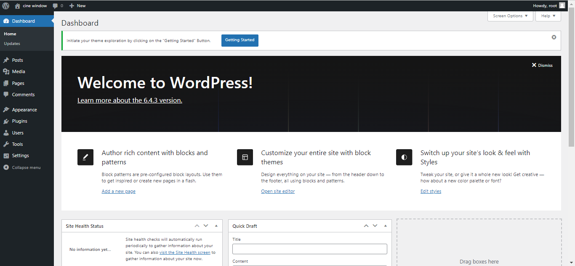

3. HOME PAGE
